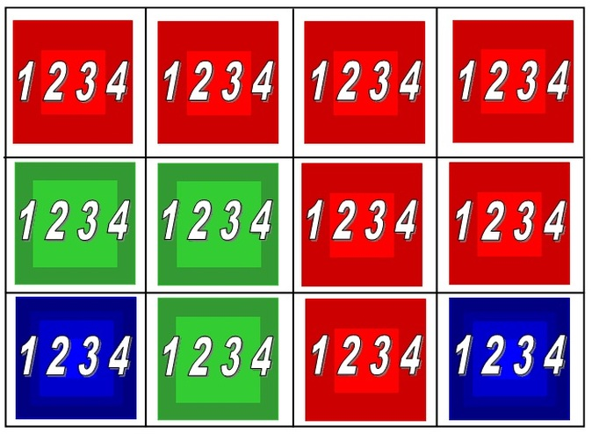

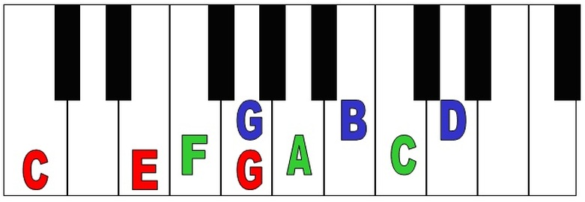

**To play the chord, all three notes need to be played at the same time.**

Chords need to be held for the whole bar in your left hand while playing the melody in with the right hand.

The colours on the 12 Bar Blues grid opposite match the colours for the Chords of C, F and G on the Ukuleles.

Can you now transfer your performance to the Ukulele?

Remember to count to four before playing the next part!

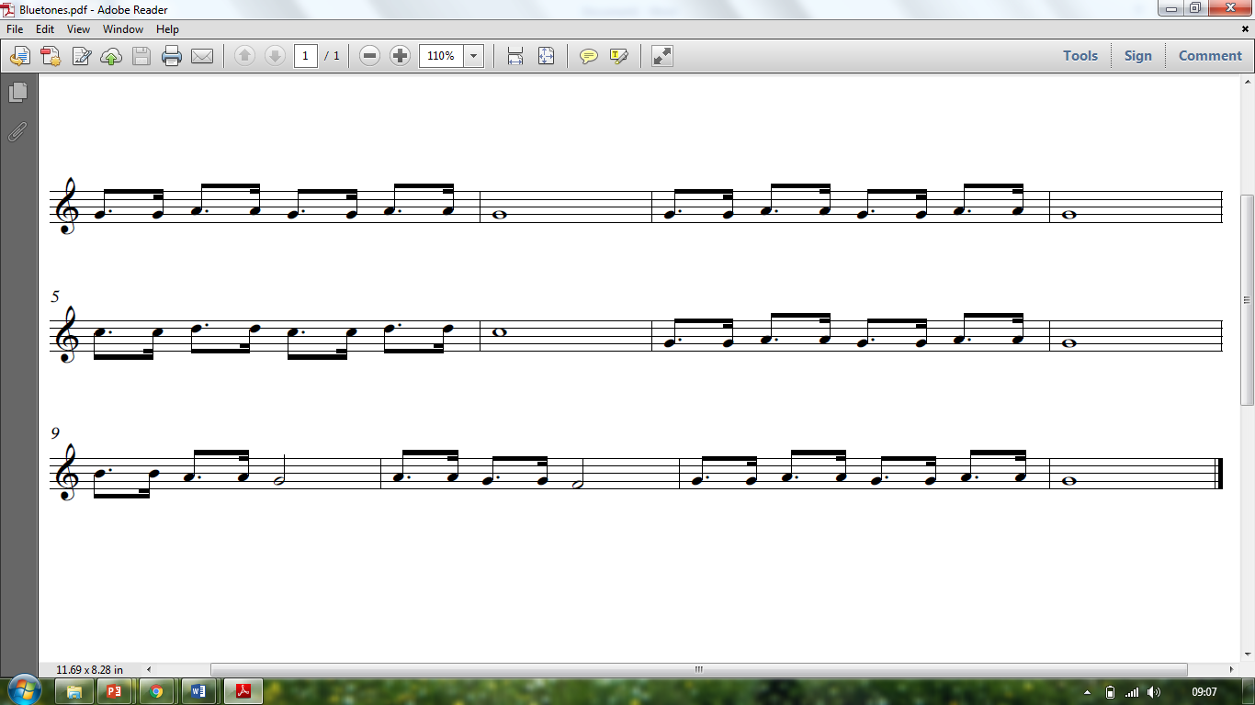

2

3

4

2

3

4

2

3

4

2

3

4

2

3

4

**C**

**C**

**F**

**C**

**G**

**F**

**C**

**C**

**C**

**C**

**F**

**G**

G

G

G

G

G

G

G

G

G

G

G

G

G

G

G

G

G

G

G

G

G

G

G

A

A

A

A

A

A

A

A

A

A

A

A

A

A

A

A

A

A

A

A

C

C

C

C

D

D

D

D

C

F

B

B

**Bluetones (12 Bar Blues)**