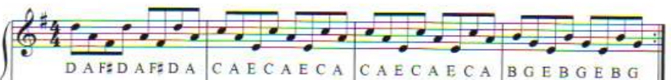
RIFF
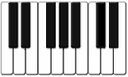
D

B

G

E

A

C

F#

Clocks Assessment
 | Riff | Chords | Bass Part | Melody
3a | Attempted to find the notes | Attempted to find the notes | Attempted to find the notes | Attempted to find the notes
4c | Find the notes of the first bar | Find the notes of the first bar | Find the notes of the first bar | Find the notes of the first bar
4b | Find and play the notes of the first and second bar | Find and play the notes of the first and second bar | Find and play the notes of the first and second bar | Find and play the notes of the first and second bar
4a | Find and play the notes of the whole section | Find and play the notes of the whole section | Find and play the notes of the whole section | Find and play the notes of the whole section
5c | Play the section slowly with some mistakes | Play the section slowly with some mistakes | Play the section slowly with some mistakes | Play the section slowly with some mistakes
5b | Play the section slowly but fairly fluently | Play the section slowly but fairly fluently | Play the section slowly but fairly fluently | Play the section slowly but fairly fluently
5a | Play the section fluently | Play the section fluently | Play the section fluently | Play the section fluently
6c | Play the Riff with the Chords or Bass Part slowly with some mistakes | Play the Chords with the Riff slowly with some mistakes | Play the Bass Part with the Riff slowly with some mistakes | Play the Melody with the Chords or Bass Part slowly with some mistakes
6b | Play the Riff with the Chords or Bass Part fairly fluently | Play the Chords with the Riff fairly fluently | Play the Bass Part with the Riff fairly fluently | Play the Melody with the Chords or Bass Part fairly fluently
6a | Play the Riff with the Chords or Bass Part fluently | Play the Chords with the Riff fluently | Play the Bass Part with the Riff fluently | Play the Melody with the Chords or Bass Part fluently
7c | Play the Riff with the Melody with some mistakes | Play the Chords with the Melody with some mistakes | Play the Bass Part with the Melody with some mistakes | Play the Melody with the Riff with some mistakes
7b | Play the Riff with the Melody fairly fluently | Play the Chords with the Melody fairly fluently | Play the Bass Part with the Melody fairly fluently | Play the Melody with the Riff fairly fluently
7a | Play the Riff with the Melody fluently | Play the Chords with the Melody fluently | Play the Bass Part with the Melody fluently | Play the Melody with the Riff fluently

CHORDS
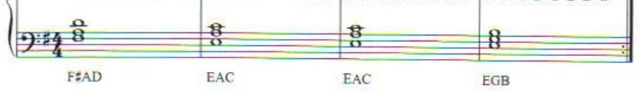
B

G

E

A

C

D

A

F#

Clocks Assessment
 | Riff | Chords | Bass Part | Melody
3a | Attempted to find the notes | Attempted to find the notes | Attempted to find the notes | Attempted to find the notes
4c | Find the notes of the first bar | Find the notes of the first bar | Find the notes of the first bar | Find the notes of the first bar
4b | Find and play the notes of the first and second bar | Find and play the notes of the first and second bar | Find and play the notes of the first and second bar | Find and play the notes of the first and second bar
4a | Find and play the notes of the whole section | Find and play the notes of the whole section | Find and play the notes of the whole section | Find and play the notes of the whole section
5c | Play the section slowly with some mistakes | Play the section slowly with some mistakes | Play the section slowly with some mistakes | Play the section slowly with some mistakes
5b | Play the section slowly but fairly fluently | Play the section slowly but fairly fluently | Play the section slowly but fairly fluently | Play the section slowly but fairly fluently
5a | Play the section fluently | Play the section fluently | Play the section fluently | Play the section fluently
6c | Play the Riff with the Chords or Bass Part slowly with some mistakes | Play the Chords with the Riff slowly with some mistakes | Play the Bass Part with the Riff slowly with some mistakes | Play the Melody with the Chords or Bass Part slowly with some mistakes
6b | Play the Riff with the Chords or Bass Part fairly fluently | Play the Chords with the Riff fairly fluently | Play the Bass Part with the Riff fairly fluently | Play the Melody with the Chords or Bass Part fairly fluently
6a | Play the Riff with the Chords or Bass Part fluently | Play the Chords with the Riff fluently | Play the Bass Part with the Riff fluently | Play the Melody with the Chords or Bass Part fluently
7c | Play the Riff with the Melody with some mistakes | Play the Chords with the Melody with some mistakes | Play the Bass Part with the Melody with some mistakes | Play the Melody with the Riff with some mistakes
7b | Play the Riff with the Melody fairly fluently | Play the Chords with the Melody fairly fluently | Play the Bass Part with the Melody fairly fluently | Play the Melody with the Riff fairly fluently
7a | Play the Riff with the Melody fluently | Play the Chords with the Melody fluently | Play the Bass Part with the Melody fluently | Play the Melody with the Riff fluently

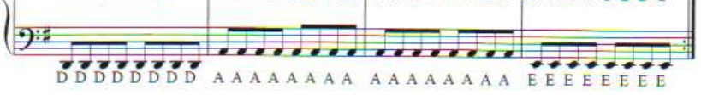
BASS PART
E
A
D
Clocks Assessment
 | Riff | Chords | Bass Part | Melody
3a | Attempted to find the notes | Attempted to find the notes | Attempted to find the notes | Attempted to find the notes
4c | Find the notes of the first bar | Find the notes of the first bar | Find the notes of the first bar | Find the notes of the first bar
4b | Find and play the notes of the first and second bar | Find and play the notes of the first and second bar | Find and play the notes of the first and second bar | Find and play the notes of the first and second bar
4a | Find and play the notes of the whole section | Find and play the notes of the whole section | Find and play the notes of the whole section | Find and play the notes of the whole section
5c | Play the section slowly with some mistakes | Play the section slowly with some mistakes | Play the section slowly with some mistakes | Play the section slowly with some mistakes
5b | Play the section slowly but fairly fluently | Play the section slowly but fairly fluently | Play the section slowly but fairly fluently | Play the section slowly but fairly fluently
5a | Play the section fluently | Play the section fluently | Play the section fluently | Play the section fluently
6c | Play the Riff with the Chords or Bass Part slowly with some mistakes | Play the Chords with the Riff slowly with some mistakes | Play the Bass Part with the Riff slowly with some mistakes | Play the Melody with the Chords or Bass Part slowly with some mistakes
6b | Play the Riff with the Chords or Bass Part fairly fluently | Play the Chords with the Riff fairly fluently | Play the Bass Part with the Riff fairly fluently | Play the Melody with the Chords or Bass Part fairly fluently
6a | Play the Riff with the Chords or Bass Part fluently | Play the Chords with the Riff fluently | Play the Bass Part with the Riff fluently | Play the Melody with the Chords or Bass Part fluently
7c | Play the Riff with the Melody with some mistakes | Play the Chords with the Melody with some mistakes | Play the Bass Part with the Melody with some mistakes | Play the Melody with the Riff with some mistakes
7b | Play the Riff with the Melody fairly fluently | Play the Chords with the Melody fairly fluently | Play the Bass Part with the Melody fairly fluently | Play the Melody with the Riff fairly fluently
7a | Play the Riff with the Melody fluently | Play the Chords with the Melody fluently | Play the Bass Part with the Melody fluently | Play the Melody with the Riff fluently

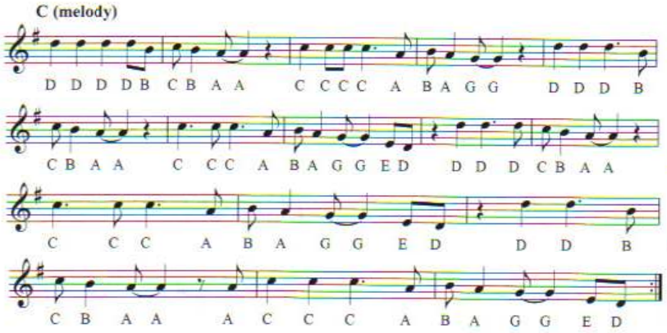
MELODY

Clocks Assessment
 | Riff | Chords | Bass Part | Melody
3a | Attempted to find the notes | Attempted to find the notes | Attempted to find the notes | Attempted to find the notes
4c | Find the notes of the first bar | Find the notes of the first bar | Find the notes of the first bar | Find the notes of the first bar
4b | Find and play the notes of the first and second bar | Find and play the notes of the first and second bar | Find and play the notes of the first and second bar | Find and play the notes of the first and second bar
4a | Find and play the notes of the whole section | Find and play the notes of the whole section | Find and play the notes of the whole section | Find and play the notes of the whole section
5c | Play the section slowly with some mistakes | Play the section slowly with some mistakes | Play the section slowly with some mistakes | Play the section slowly with some mistakes
5b | Play the section slowly but fairly fluently | Play the section slowly but fairly fluently | Play the section slowly but fairly fluently | Play the section slowly but fairly fluently
5a | Play the section fluently | Play the section fluently | Play the section fluently | Play the section fluently
6c | Play the Riff with the Chords or Bass Part slowly with some mistakes | Play the Chords with the Riff slowly with some mistakes | Play the Bass Part with the Riff slowly with some mistakes | Play the Melody with the Chords or Bass Part slowly with some mistakes
6b | Play the Riff with the Chords or Bass Part fairly fluently | Play the Chords with the Riff fairly fluently | Play the Bass Part with the Riff fairly fluently | Play the Melody with the Chords or Bass Part fairly fluently
6a | Play the Riff with the Chords or Bass Part fluently | Play the Chords with the Riff fluently | Play the Bass Part with the Riff fluently | Play the Melody with the Chords or Bass Part fluently
7c | Play the Riff with the Melody with some mistakes | Play the Chords with the Melody with some mistakes | Play the Bass Part with the Melody with some mistakes | Play the Melody with the Riff with some mistakes
7b | Play the Riff with the Melody fairly fluently | Play the Chords with the Melody fairly fluently | Play the Bass Part with the Melody fairly fluently | Play the Melody with the Riff fairly fluently
7a | Play the Riff with the Melody fluently | Play the Chords with the Melody fluently | Play the Bass Part with the Melody fluently | Play the Melody with the Riff fluently

