Composition using ‘Ode To Joy’ Notes

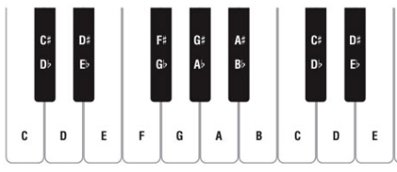

**Repeated Gaps 1 beat notes Start and end**

**pattern 2 beat notes on C**

**C _ _ _ _ _ _ _ , _ _ _ _ _ _ _______**

**C _ _ _ _ _ _ _ , _ _ _ _ _ _ _______**

**Names: ___________and ___________**

**Melody**

**Use ONLY these notes!**