How did you **overcome your difficulties** today?

Draw a picture to represent a **key** **word** from today’s lesson

Name: _____________________________________________

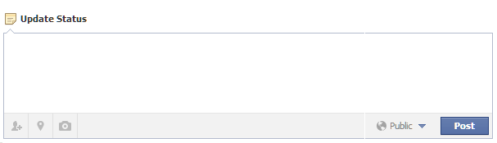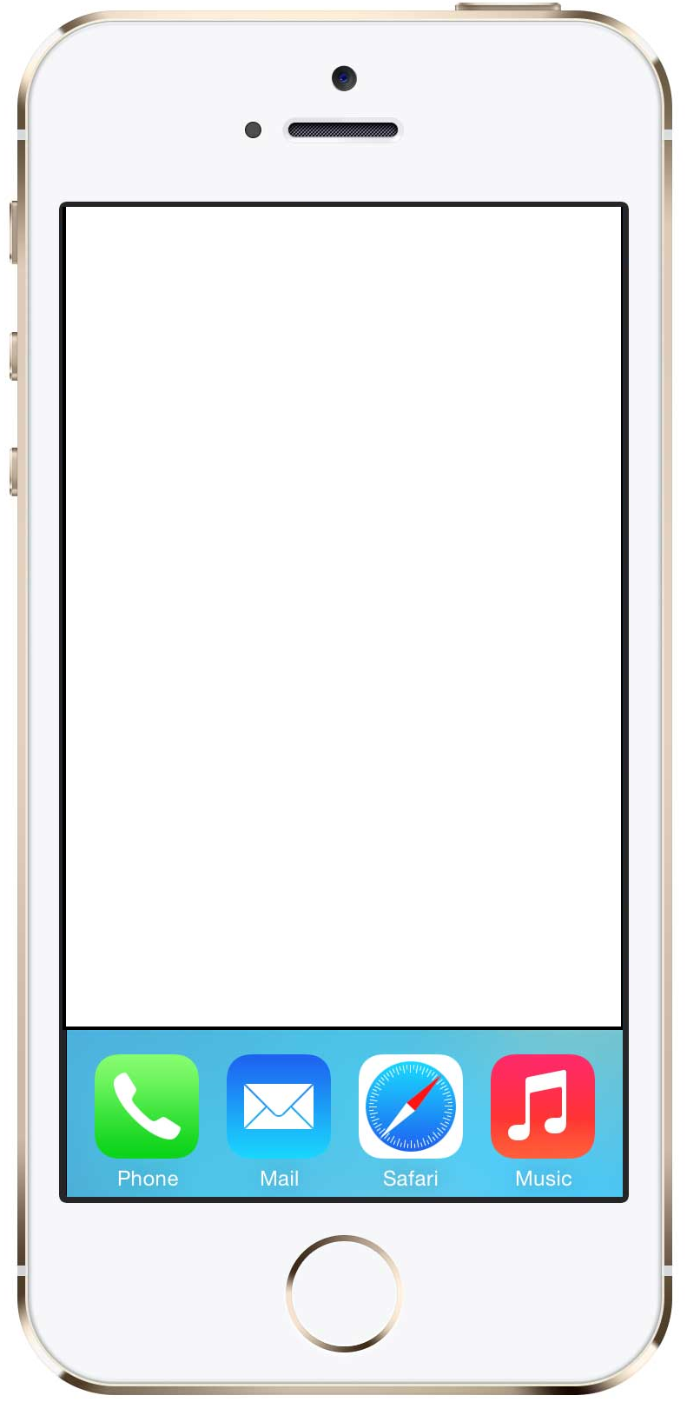

Send a text to your friend about **what you learnt** today

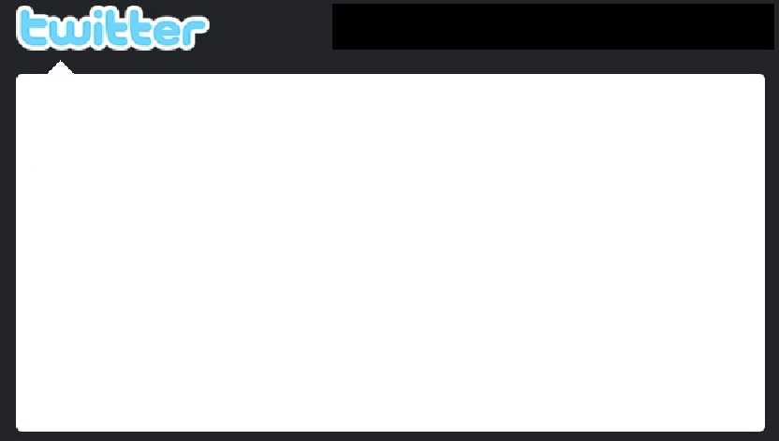

Send a tweet about what **skills** you used today #skills

Reflect on your learning today by completing the social media boxes.

