GCSE Music Unit 1
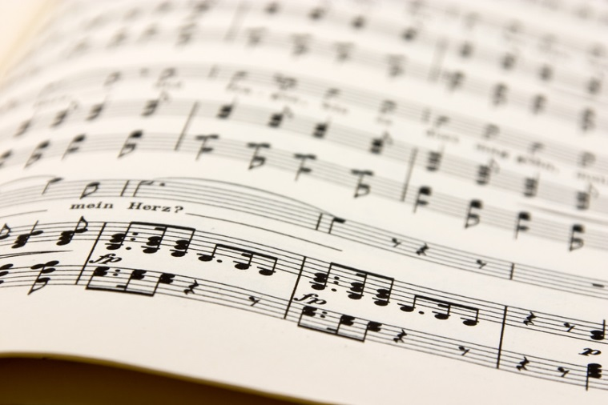
Name: _________________________

Area of Study 1 – Rhythm & Metre

Definition of metre: ___________________________________________
____________________________________________________________
Definition of rhythm: __________________________________________
____________________________________________________________
Metre keywords:

Rhythm keywords:

Listening & Appraising AoS 1
“Winter”(Movement I) from The Four Seasons by Vivaldi
- What is the metre? _____________________________________
- Give an appropriate tempo direction: _______________________

“Do you hear the people sing?” from Les Miserables
- Identify the rhythm used for the line “Do you hear the people”: ________________________________________________________
- Give a suitable tempo direction: _____________________________
“Amazing Grace” by John Newton
- What is the metre? _____________________________________

“Ride of the Valkyries” by Wagner
- What is the time signature? _____________________________
- How many bars are there until the brass enter? _____________

“Neptune” from The Planets Suite by Holst
- What is the time signature? _____________________________

Irish Washerwoman (traditional)
- What is the time signature? ______________________________

“We are young” by Fun
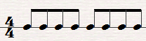
- Write accents above the correct notes to identify the articulation (drum part)

“The Tracks of my tears” by Smokey Robinson
- What is the rhythm for the lines: “look at my” and “looks out of”
_______________________________________________________

“Billionaire” by Bruno Mars
- Describe the rhythm of the acoustic guitar: ________________________
Area of Study 2 – Harmony & Tonality

Definition of harmony: ___________________________________________
____________________________________________________________
Definition of tonality: __________________________________________
____________________________________________________________
Harmony keywords:

Tonality keywords:

Listening & Appraising AoS 2
“Smooth Criminal”, by Michael Jackson
- What is the tonality? _____________________________________

“Canon in D” by Pachelbel
- What harmonic device is used in this piece? ___________________
- What is the tonality? ______________________________________
Theme music from Law & Order: UK
- What is the cadence at the end of the first phrase? _________________
- What is the cadence heard at the end? ___________________________

“Dear Darlin’” by Olly Murs
- How many different chords are there (verse)? _____________________
- What is the harmonic device heard in the strings at the end of the excerpt? ______________

“Pierrot Lunaire” by Shoenberg
- What is the tonality? _________________

“I’m Leavin’ You” by Howlin’ Wolf
- What is the cadence in bars 11-12 of the verse? ___________________

“Yellow Bird” by the Red Stripe Ebony Band
- How many different chords are there? ___________________

“Love on top” by Beyonce
- What happens to the tonality as the excerpt progresses? _____________
_______________________________________________________________
CLUE: listen carefully to the line “love on top”

Area of Study 3 – Texture & Melody

Definition of Texture: ___________________________________________
____________________________________________________________
Definition of Melody: __________________________________________
____________________________________________________________
Texture keywords:

Melody keywords:

Listening & Appraising AoS 3
“Some Nights” by Fun
- What is the texture at the start? _________________________________
- How does the texture change in the verse? ________________________

“Toccata and Fugue in D minor” by Bach
- What texture is heard throughout the excerpt? ____________________

“Angels from the Realms of Glory“(David Archuleta version)
- Describe the melody for the word “Gloria”? _______________________
- What type of voice sings the melody? ____________________________
- How is the melody decorated on the word “high”? __________________
- How is the melody decorated on the word “deo”? __________________

“Sumer is icumen in” performed by Lumina Vocal Ensemble
- Name two textures that are used in this excerpt? ______________

“Bateria samba brasil Batucada”

- Name three different textures used in this excerpt? ________________
_____________________________________________________________

“Rhapsody in Blue” by Gershwin
- Which 2 terms describe the opening clarinet melody?
GLISSANDO MORDENT TRILL AUGMENTATION DIMINUTION PASSING NOTE PITCH BEND

“Thrift Shop” by Macklemore (clean!)
- Describe the saxophone part: ___________________________________
Area of Study 4 – Timbre & Dynamics

Definition of Timbre: ___________________________________________
____________________________________________________________
Definition of Dynamics: __________________________________________
____________________________________________________________
Timbre keywords:

Dynamics keywords:

Listening & Appraising AoS 4

“Summertime” by Miles Davis
- What instrument plays the melody? ___________________________
- What gives it the unique timbre? _____________________________

“Radioactive” by Chasing Dragons
- What percussion instrument features in the chorus? _________________

“String of Pearls” by Glenn Miller
- What technique is used by the woodwinds? _______________________
- What ensemble is performing? _________________________________
- Describe how the dynamic changes between the two opening woodwind phrases: ____________________________________________________

Symphony No.1 (Movement III) by Mahler
- Which instrument plays the opening melody? ______________________
- Which instrument takes over the melody? _________________________
BONUS: describe how the texture changes: ___________________________

Symphony No.7 (Movement I) by Beethoven
- The opening melody line is passed around which instrument family? _______________________________
- What are the first two instruments which perform the melody? _______________________________________________________

“Pancham Se Gara” by Anoushka Sancha
- What three instruments can you identify? _______________________
_____________________________________________________________
- Name an additional, traditional Indian instrument: _______________
Area of Study 5 – Structure & Form

Definition of Structure: ___________________________________________
____________________________________________________________
Definition of Form: __________________________________________
____________________________________________________________
Structure keywords:

Form keywords:

Listening & Appraising AoS 5
“Son of a preacher man” by Dusty Springfield
- What is the name for the section after the second chorus? ____________
- What in the music changes at this point? __________________________
____________________________________________________________________________________________________________________________________________________________________________________

K.265 by Mozart
- What is the overall form of this excerpt? __________________________

K.525 (Movement III) by Mozart (approx. 0.00-0.45)
- What is the structure of this excerpt?
AABA AABB ABA AABBA

BWV – 1049 by Brandenburg
- What is the term used to describe this musical form?

RECORDER CONCERTO SYMPHONY CONCERTO GROSSO

VIOLIN CONCERTO SONATA

Clarinet Concerto No.1 (Movement I) by Weber (approx. 3.45-4.25)
- What is term used to describe the exposed solo in this excerpt?

__________________________________________________________

“Blue...a la turk” by Brubeck
- What is the musical form to describe this excerpt? _____________

“Guide me O thou great Jehovah” by John Hughes
- Select the correct term to describe the form of this excerpt

THROUGH-COMPOSED TERNARY STROPHIC

ARCH-SHAPE BINARY

Notes

Homework

On going...
- Revise the keywords for each Area of Study – test yourself & get others to test you
- When listening to music, analyse it for use of keywords
- When practising, consider how the music you are learning uses each of the Areas of Study
- Improvise or compose on your instrument using the keywords – can you perform a sequence? Can you demonstrate a trill? Can you play a tune that uses a mode?
- Attend the Unit 1 revision sessions
- Use the GCSE Music text books in the department for independent revision
- Go back over the questions covered in class – listen to the excerpts and check your understanding

Additional...
- Revision games
- Mock exam(s)
- Presentations

To be submitted...
- Your own exam question. Select a piece of Music and choose 1-2 minutes of it to analyse (no score required). Create an exam question which has at least 5 parts. Try to use all the AoS.

1a – Popular Music of 21st Century

1b – Western Classical Tradition

1c – World Music

1d – Popular Music of 21st Century

1e – Western Classical Tradition

1f – World Music

- A mind map showing your understanding of each AoS.

2a – AoS 1 – Rhythm & Metre

2b – AoS 2 – Harmony & Tonality

2c – Aos 3 – Texture & Melody

2d – AoS 4 – Timbre & Dynamics

2e – AoS 5 – Structure & Form

